Initial Health Appointment Delegation Oversight Audit Inservice Form
Delegate Name |  | Facilitator
Provider/Clinic Name

Initial Health Appointment Training
Initial Health Appointment (IHA) Overview | - The Initial Health Appointment (IHA) is a requirement for all new San Francisco Health Plan (SFHP) Medi-Cal members as indicated in the DHCS All Plan Letter (APL) 26-001. It is a comprehensive assessment that must be completed within 120 calendar days of enrollment with SFHP or documented within the 12 months prior to Plan enrollment/PCP effective date.  - During the IHA, the primary care provider assesses and manages the acute, chronic, and preventative health needs of the member that are culturally and linguistically appropriate for the members.  - The requirements can be completed over the course of multiple visits. One or more components of the IHA can be completed via telehealth. However, not all components may be achieved via telehealth. For IHAs conducted via telehealth, Medi-Cal requires a subsequent in-person, comprehensive physical exam.  - The IHA includes a history of the member’s physical and behavioral health, an identification of risks, an assessment of need for preventive screens or services and health education, and the diagnosis and plan for treatment of any diseases.  - Note: Health Information Form (HIF)/Member Evaluation Tool (MET) that addresses the needs of Seniors and People with Disabilities (SPDs) is required to be completed within 90 days of enrollment for new members or transitioning members between health plans. IHA results that are completed and shared back with the MCP within 90 days of enrollment would fulfill the HIF/MET requirement
Outreach Attempts | - If an IHA is not found in the medical record, the reasons (e.g., member/parent refusal, missed appointment) and contact attempts to reschedule are documented.  - Providers are required to make at least two documented outreach attempts by phone and one written outreach to contact new members for scheduling the IHA.  - All efforts, including refusals or no-shows, must be recorded in the medical record.  - We encourage providers to download their new member rosters from Provider Portal. Instructions on how to download lists can be found on the Provider Portal User Guide.
History of the member’s physical | History of the member's physical to include:  - Physical Exam (PE)/Review of Systems (ROS)  - Dental ROS documentation that indicates “inspection of mouth” or “seeing dentist” meets PE criteria  - History of present illness (HPI)  - Past medical history (PMH)
History of the member’s behavioral health | History of member’s behavioral health should include: brief emotional/behavioral assessment (e.g., depression inventory, attention deficit/ hyperactivity disorder [ADHD] scale), with scoring and documentation, per standardized instrument.
  Example of Some Tools | Ages
  Ages and Stages Questionnaire: Social-Emotional (ASQ-SE or ASQ:SE-2) | 1 to 72 months
  Survey of Wellbeing of Young Children (SWYC) | 1-65 months
  Strengths and Difficulties Questionnaire (SDQ) | 2–17 Preschool version: 2– 4 School-aged: 4–10 Adolescent : 11–17 Self-report measure for 11- to 17- year-old as well as age 18 and older
  Pediatric Symptom Checklist (PSC) | as young as 4 years old
  Patient Health Questionnaire, (PHQ-2) (If positive, administer PHQ-9) | 12+
  General Anxiety Disorder (GAD-7) | 11+
Identification of risks | Initial HRA related to health and social needs of members, including cultural, linguistic, and health education needs; health disparities and inequities; lack of coverage/access to care; and social drivers of health (SDOH). At least ONE risk assessment tool meets the standard.  Examples of tools:  - Health Risk Assessment (HRA) (Pediatric and Adult)  - Social Determinants of Health (SDOH) (Pediatric and Adult)  - The AAFP Social Needs Screening Tool  - PRAPARE (The Protocol for Responding to and Assessing Patients' Assets, Risks, and Experiences)  - AHC-HRSN (Accountable Health Communities Health-Related Social Needs) Screening Tool  - Adverse Childhood Experiences (ACEs) (Pediatric and Adult)  - PEARLS ACE (Pediatric ACEs and Related Life-events Screener):  - PEARLS child tool, for ages 0-11, to be completed by a parent/caregiver.  - PEARLS adolescent tool, for ages 12-19, to be completed by a parent/caregiver.  - PEARLS for adolescent self-report tool, for ages 12-19, to be completed by the adolescent.  - ACE Questionnaire for Adults (18+)  - Cognitive Health Assessment (Adults Only-65+)  - General Practitioner Assessment of Cognition (GPCOG)  - Mini-Cog  For positive findings, order as appropriate and follow up as needed
Assessment of need for preventive screens or services | - Administration of preventive services will no longer be required to be completed during the IHA as long as members receive all required screenings in a timely manner consistent with guidelines, including:  - Members ages 18 and up: PCP provides preventive services by most recent edition of the Guide to Clinical Preventive Services of the US Preventive Services Task Force Grade A and B recommendations for providing preventive services, testing, and counseling services.  - Members under 21 years of age: For children and youth (i.e., individuals under age 21), Early and Periodic Screening, Diagnostic and Treatment (EPSDT) screenings will continue to be covered in accordance with the American Academy of Pediatrics (AAP)/Bright Futures periodicity schedule, as referenced in APL 23-005. PCP provides preventive services specified by the most recent American Academy of Pediatrics/Bright Futures age-specific guidelines and periodicity schedule.  - Perinatal services: PCP provides services according to the most current standards of the American College of Obstetrics and Gynecology (ACOG) guidelines.  - Immunizations according to CDC’s most recent Advisory Committee on Immunization Practices (ACIP) guidelines for adults and pediatrics. Providers are required to use the California Immunization Registry (CAIR).
Health education | - Provide health education and anticipatory guidance according to but not limited to age, risk factors, or acute/chronic continuous conditions to promote injury and disease prevention  - Anticipatory Guidance can be found on the American Academy of Pediatrics (AAP) Bright Futures website at aap.org/en/practice-management/bright-futures/bright-futures-materials-and-tools/bright-futures-guidelines-and-pocket-guide/
Diagnosis and plan for treatment of any diseases | - Diagnosis of diseases  - Plan of treatment for any disease or health condition identified  - The IHA must include the identification of specialty care needed and the initiation of appropriate referrals and labs. Care coordination is a foundational component of the IHA to ensure the member receives the follow-up services identified during the exam.
Closed Loop Management | - Closed-loop processes must be applied to both referrals and ordered labs/diagnostics, meaning they are not only initiated but tracked through completion. The PCP or care team is responsible for confirming that:  - The member schedules and completes referred specialty appointments and completes all ordered labs and diagnostic tests.  - Results from specialists, labs, and diagnostic studies are received, reviewed, and documented in the medical record.  - Findings are incorporated into the member’s care plan and communicated to the member as appropriate.  - Any missed, delayed, or incomplete referrals or lab services are actively followed up with documented outreach efforts and interventions to address barriers (e.g., scheduling, transportation, health literacy).  - All components of the closed-loop process—including referrals, lab completion status, outreach attempts, barrier resolution, and follow-up actions—must be clearly documented in the medical record to demonstrate continuity of care and compliance with care coordination standards.
IHA Clinical Guide With Coding Tips
Visit SFHP Website for the IHA Clinical Guide with Coding Tips: https://www.sfhp.org/providers/improving-quality/initial-health-appointment/

IHA Primary Care Office Flow Map Example

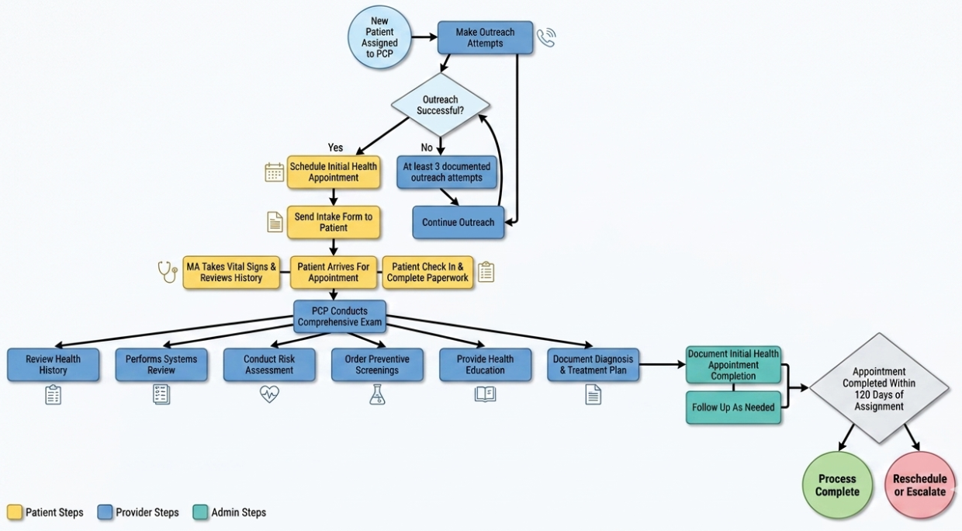

What Constitutes Closed‑Loop Referral Management
A referral is considered closed when the PCP has taken all reasonable steps to initiate and follow up on the referral and has documented the outcome or next clinical steps. Closed‑loop referral completion is based on provider assessment and documented resolution—not on whether an external specialist or agency responds.

Approach | What the PCP Does | What to Document | Loop Considered Closed When…
Time Bound Escalation | Sends referral with defined 2–3 follow-up attempts over set timeframe | Dates, methods, and final nonresponse noted | Final attempt completed and disposition recorded
Patient Attested Outcome | Asks patient about referral outcome | Patient report (seen, declined, unable to schedule) and date | Patient outcome guides next clinical action
Clinical Substitution | PCP manages condition or refers to alternate service | Reason referral no longer needed and new plan | New care plan implemented
Formal Referral Closure | Closes referral with reason code in EMR | Closure reason (e.g., unresponsive, declined) | Referral status set to “closed”
Plan / Network Escalation | Escalates once to health plan or network | Date and entity escalated to | Escalation completed and next steps decided
Provider Attestation | PCP determines no further attempts are needed | Statement of due diligence and clinical judgment | Attestation documented
Referral Expiration Policy | Applies clinic defined expiration timeframe | Expiration date and PCP review note | Referral expires with documented resolution

Closed Loop Referral Management Flow Map Example
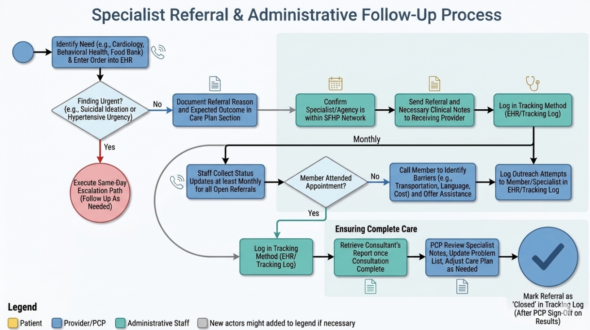

Sample of Medical Assistant Standard Work Instruction Sheet

MA Standard Work Instruction Sheet
Initial Health Appointment and Subsequent Annual Visits
Commit to a process but be flexible if something isn't working. If after adhering to a clear workflow your team runs into issues, regroup and rework the workflow. Use questions on next page to evaluate your process.
Before your team rolls out the plan, work together to determine a process and commit to it for a few weeks. Designate clear roles, asking each other who in your clinic should:

- Identify and become familiar with the questionnaire to be used.
- Explain questionnaire to the patient in culturally sensitive manner.
- Ensure the clinic has enough copies of the questionnaire
- Ensure material is in all the languages spoken by your patient population.
- Provide privacy for the patient to complete the questionnaire.
- Transfer the paper information into the EMR if applicable.
- Flag the “positive” responses for the provider.
Description |  | Patients coming for well-visits or yearly physicals
Tools/Supplies Needed |  | Initial Health Appointment Questionnaire and Health Risk Assessment Tool
Method for Completing: |  | 1. Mail to patient.  2. Schedule patient to arrive to IHA appt. 45 minutes early with MA assistance.  3. Instruct patient to complete questionnaire online (e.g, MyChart).
Operator(s) |  | Administrative and Clinical Staff | Estimated Avg Intake Time:
STEP | OPERATOR | TASK DESCRIPTION | Why
NO. | (Who) | (What)
1 | NA | Choose most appropriate method to administer questionnaire based on patient. | To ensure the patient or representative has time to review the document prior to the visit with the provider.
2 | MA | MA to collect the completed form from the patient/parent/guardian. | To ensure that the form is given to the provider.
3 | MA | MA to give the completed form to the provider prior to seeing the patient. | To ensure the provider has time to review the form prior to the visit.
4 | Provider | Reviews the form with the patient/parent/ guardian.
5 | MA | Scan the completed form into the patient's chart attached to the associated visit at the end of the visit or maintain medical records if site has only paper chart. | To ensure that the form is documented in EMR or filed in paper chart.

Print Name | Title | Date | Signature

