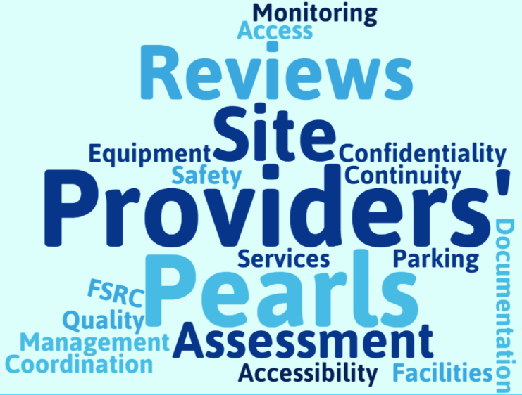
IHA Provider Newsletter Sample



Medical Record Review: Initial Health Appointment (IHA) and Health Risk Assessment (HRA)

The Initial Health Appointment (IHA) occurs during a patient’s visit with a provider in the primary care setting within 120 calendar days of enrollment to the plan. The IHA is used to assess and manage any acute, chronic, and preventative health needs of the patient. Completing the Initial Health Appointment (IHA) timely provides an opportunity for new Medi-Cal and dually eligible for Medi-Cal and Medicare patients to establish a relationship with their PCP and obtain necessary health care and preventative services, which can lead to positive health outcomes and improvement in their overall health status. It can be completed across multiple visits but must be completed within 120 calendar days of enrollment with SFHP, and should be documented in the member's medical record.

The California Department of Health Care Services (DHCS) Medical Record Review (MRR) process includes an evaluation of a primary care provider’s (PCP) documentation of a member’s comprehensive physical examination, including a review of systems with a plan for treatment for any identified acute or chronic diseases or conditions. But that is just the beginning. Comprehensive visits for new members and for their subsequent periodic well visits also are to include behavioral health assessments, social determinants of health (SDOH) assessments, identification of preventive screenings, immunization review, provide health education and anticipatory guidance.

In addition, as part of the Facility Site Review (FSR) component of the review process, the site reviewer will evaluate office management practices on appointment guidelines for same-day appointments, after hours availability, how members receive care when they are sick, advice guidelines, complex health care needs guidance, care coordination, complex case management, enhanced care management, or community supports, language interpretation guidance, and transportation guidance. These factors ensure that any needs of members identified through the IHA process can be addressed and remedied through strong office management practices.

SFHP has some tip sheets that you may wish to review and apply to your office management practices so that you are prepared and in compliance with all DHCS requirements for these criteria.

MRR Comprehensive Physical Exam with IHA & HRA  Click link below | IHA Tip Sheet  Click link below
Provider Newsletter May 2026  IHA Excellence: Coding and the Initial Health | IHA_Clinical_Guide_with_Coding_Tips.pdf

Comprehensive Physical Exam |  |   Health Risk Assessment
Brief emotional/behavioral assessment |  | At least ONE risk assessment domain meets the standard
Depression Screening | Psychosocial/  Behavioral Assessment | Member Risk Assessment  (*Site specific for members <21) | Member Risk Assessment  (Adults) | Cognitive Assessment (Member tool) | Cognitive Assessment (Informant tools)
12+ | *18 to 21 years | *18 to 21 years | 18+ | 65+ | 65+
PHQ-2 | AAFP Social Needs Screening Tool | AHC HRSN | AHC-HRSN | CPCOG | IQCODE
PHQ-9 | GAD-7 | PRAPARE | Your Current Life Situation | Mini-Cog | AD8
PHQ-9A  modified for teens | Other Social Needs Screening Tools | We Care | AAFP Social Needs Screening Tool
 |  | PEARLS | ACE for adults

Social Determinants of Health Validated Screening Tools
GAD = General Anxiety Disorder
ACE = Adverse Childhood Experiences

Note: Validated Screening Tools shown are examples of those most commonly used.

MA Standard Work Instruction Sheet
Initial Health Appointment and Subsequent Annual Visits
Commit to a process but be flexible if something isn't working. If after adhering to a clear workflow your team runs into issues, regroup and rework the workflow. Use questions on next page to evaluate your process.
Before your team rolls out the plan, work together to determine a process and commit to it for a few weeks. Designate clear roles, asking each other who in your clinic should:

- Identify and become familiar with the questionnaire to be used.
- Explain questionnaire to the patient in culturally sensitive manner.
- Ensure the clinic has enough copies of the questionnaire
- Ensure material is in all the languages spoken by your patient population.
- Provide privacy for the patient to complete the questionnaire.
- Transfer the paper information into the EMR.
- Flag the “positive” responses for the provider.
Description |  | Patients coming for well-visits or yearly physicals
Tools/Supplies Needed |  | Initial Health Appointment Questionnaire and Health Risk Assessment Tool
Method for Completing: |  | 1. Mail to patient.  2. Schedule patient to arrive to IHA appt. 45 minutes early with MA assistance.  3. Instruct patient to complete questionnaire online (MyChart).
Operator(s) |  | Administrative and Clinical Staff | Estimated Avg Intake Time:
STEP | OPERATOR | TASK DESCRIPTION | Why
NO. | (Who) | (What)
1 | NA | Choose most appropriate method to administer questionnaire based on patient. | To ensure the patient or representative has time to review the document prior to the visit with the provider.
2 | MA | MA to collect the completed form from the patient/parent/guardian. | To ensure that the form is given to the provider.
3 | MA | MA to give the completed from to the provider prior to seeing the patient. | To ensure the provider has time to review the form prior to the visit.
4 | Provider | Reviews the form with the patient/parent/ guardian.
5 | MA | Scan the completed form into the patient's chart attached to the associated visit at the end of the visit. | To ensure that the form is documented in Epic.

Primary Care - IHA Office Flow Map
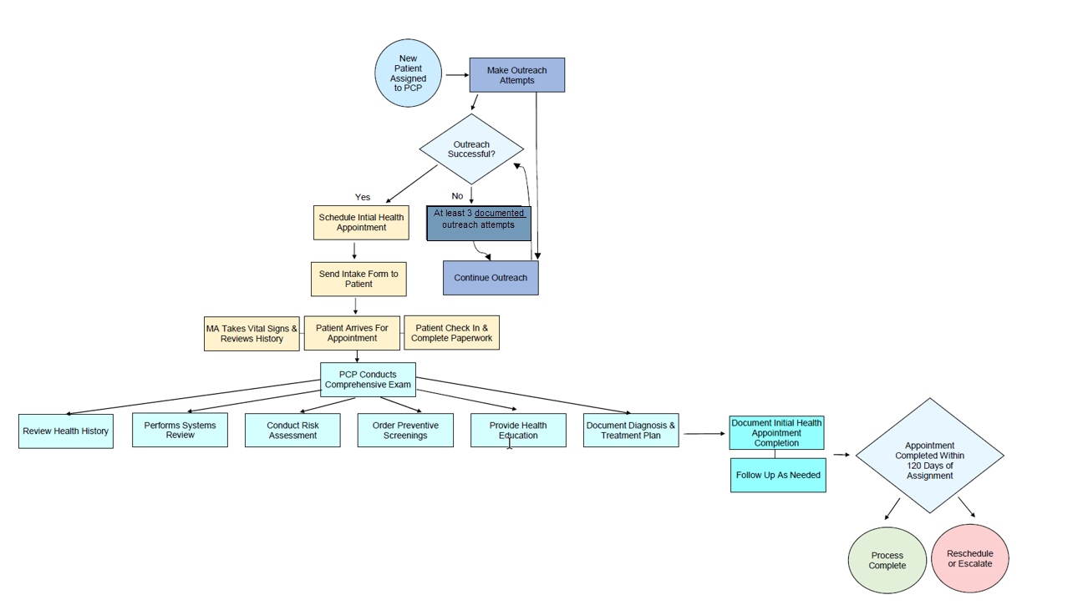

A Checklist for Reviewing Your Implementation Progress:
- Questions for your practice or team Yes No
- If, “No,” how can you improve this part of the assessment process?
- In general, are patients completing the health assessments as expected?
- In general, are patients responding positively to the assessment?
- Are you reaching all or most of the patients you wanted to with the assessment?
- Can most patients complete the assessment in a timely manner?
- Do patients routinely complete all the questions on the assessment?
- Are staff members able to review the completed assessments as expected?
- Are clinicians able to review the completed assessments as expected?
- Are the clinicians in the practice providing acknowledgment and feedback to patients as expected?
- Are assessments being entered into patient charts correctly?
- Are you able to respond to “positives” as expected?
- Do you have data to show how the practice has improved screening/assessment rates?

References:

Accountable Health Communities Health-Related Social Needs Screening Tool Citation and Notification Information
All Plan Letter (APL) 26-001 Initial Health Appointment
All Plan Letter (APL) 23-021 Population Needs Assessment And Population Health Management Strategy
All Plan Letter (APL) 23-034 California Children’s Services (CCS) Whole Child Model (WCM) Program
All Plan Letter 21-009 (Revised) Collecting Social Determinants Of Health Data
Factsheet: California Advancing and Innovating Medi-Cal (CalAIM) Population Health Management Initiative
Risk-Stratification Algorithm, American Academy of Family Physicians (2019)
Screening for Behavioral Health Conditions in Primary Care Settings: A Systematic Review of the Literature - PMC (nih.gov)
The Accountable Health Communities Health-Related Social Needs Screening Tool
United States Preventive Services Task Force (USPSTF) https://uspreventiveservicestaskforce.org/uspstf/home

For any questions about the processes or tools, please contact [Delegate email].

